A1 CHRISTMAS PARTY
6:00 PM Welcome speech and introductions Host
6:05 PM Prayer AVP
6:10 PM Opening Message Boss Gilbert
6:35 PM Intermission Number
6:40 PM Ice Breaker (Game 1: Garter Game)
7:00 PM Raffle
7:10 PM Game 2: Counting Game
7:25 PM Intermission Number
7:30 PM Blessing of the Food Ma’am Nens
7:35 PM Dinner
8:15 PM Raffle
8:20 PM Game 3: In Out Left Right
8:35 PM Game 4: Whitney Houston Challenge
8:40 PM Intermission Number
8:45 PM Exchange Gift
9:00 PM Closing Message Ma’am Nens
9:10 PM Onwards Karaoke Night
Game Options:
[ Main Games ]
Garter Game (10 Players)
Counting Game (10 Players)
In Out Left Right (6 Players)
Whitney Houseton Challenge (6 Players)
[ If walang intermission number ]
Marching Game (6 Players)
Red Yellow Green Game (10 Players)
Hep Hep, Hooray! (Love, Joy Hope Version) (10 Players)
Mind games (10 Players)
HOSTING SCRIPT
Manel Intro
Good evening everyone! Welcome to our program for tonight!
I am Manel and together with Ma’am Nens, we will be your hosts for the night.
Thank you all for joining us as we celebrate this special gathering. So ngayong gabi walang tayong ibang gagawin kundi magrelax, magsaya, and mag-enjoy kasama ang bawat isa. So sit back, participate, and most of all—enjoy the night!
To officially start our program, may I call on everyone to please stand as we begin with a prayer.
6:05 PM – Prayer
AVP Playing
6:10 PM – Opening Message
To formally open our program, we are honored to have an opening message from Boss Gilbert. Let us all give him a warm round of applause.
(After message)
Thank you very much, Boss Gilbert, for that inspiring message.
6:35 PM – Intermission Number
Ready na ba kayo? Bago tayo magenjoy sa mga laro, dumako muna tayo sa isang intermission number na ibibigay ni kuya/ate..
6:40 PM – Ice Breaker (Game 1: Garter Game)
10 Players: Nakaform ng circle and nakapasok ang players sa garter. May music na magplaplay and kapag nagstop yon kailangan nyong makaalis sa garter. Kung sino yung maiwan sa loob ng garter, out na sya sa game.

7:00 PM – Raffle
It’s now time for our first raffle draw.
(After raffle)
Congratulations to all our winners!
7:10 PM – Game 2: Counting Game
Let’s continue with another fun game
10 Players: Count in sequence, kahit sino pwedeng magheadstart, kapag may nakasabay kayong magbilang or magbanggit ng number out na kayo pareho sa game
7:25 PM – Intermission Number
Before we move on, let’s enjoy another intermission number. Please give them a big hand!
7:30 PM – Blessing of the Food
As we prepare to enjoy our dinner, may I request everyone to please stand for the blessing of the food, to be led by Ma’am Nens.
7:35 PM – Dinner
8:15 PM – Raffle
Sana nagenjoy kayong lahat sa foods.
Now it’s time for another raffle draw. Good luck to everyone!
8:20 PM – Game 3: In, Out, Left, Right
6 Players: May paper na tatapakan and need to follow the command of the host whether left direction kayo pupunta or right, in, out kayo sa paper.
8:35 PM – Game 4: Whitney Houston Challenge
6 Players: Need masabayan yung beat ng drum sa kanta ni Whitney Houston

8:40 PM – Intermission Number
Let’s enjoy another intermission number. Please give her/him a round of applause!
8:45 PM – Exchange Gift
It’s now time for our Exchange Gift.
9:00 PM – Closing Message
As we come to the end of our formal program, may I call on Ma’am Nens for the closing message. Let’s give her a warm applause.
(After message)
Thank you very much, Ma’am Nens.
Manel Outro / 9:10 PM Onwards – Karaoke Night
Thank you everyone for being part of tonight’s celebration. We hope you had a wonderful time.
And for those who want to extent the fun, don’t worry as our Karaoke Night is officially open. Sing your heart out and enjoy the rest of the evening!
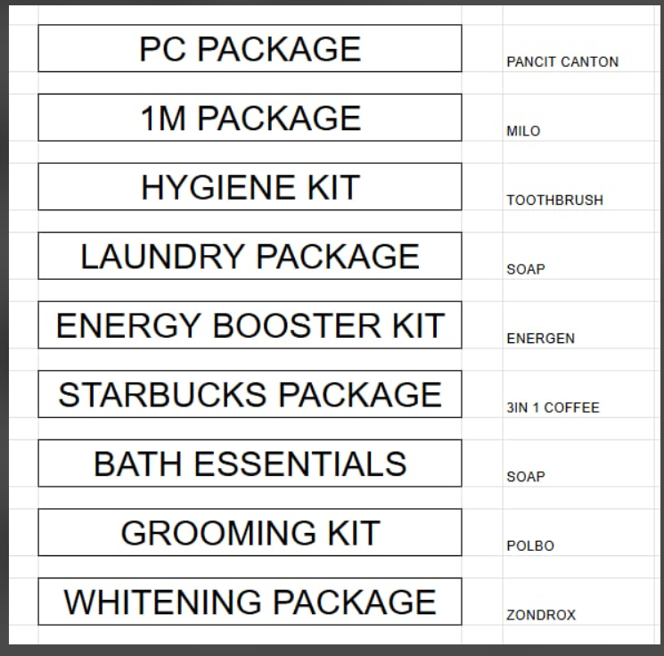
Once again, thank you and have a great night, everyone!
Game Prices
Mind Game Categories
10 Player
- Pagkain na nagsisimula sa letter S
- Gamit sa bahay na nagsisimula sa letter T
- Bagay dito sa loob ng A1 na nagsisimula sa letter P
- Lugar sa Pilipinas na nagsisimula sa letter B [Baguio, Boracay, Bohol, Batangas, Bulacan, Bacolod, Bukidnon, Bataan, Baybay, Biñan]
- Pagkain na nagsisimula sa letter S
- Drinks/Inumin na nagsisimula sa letter G
Marching Game
6 Players: Nasa loob ng box ang players, nakamask, and magmamarch for 2-3 minutes. Kung sino ang player na hindi nakalabas or nakalayo sa box nya, sya ang mananalo.
Red Yellow Green Game
10 Players: May tatlong colors na lilinyahan ang mga players, kung sino ang matira sya ang panalo. Nakamask din sila dito.
Hep Hep, Hooray! (Love, Joy Hope Version)
10 Players: Last man standing wins

